**Laporan Praktikum Pemrograman Web**

**CodeLab Modul 1**



**Dosen Pembimbing : Christian Sri Kusuma Aditya, S.Kom., M.Kom**

**Kemaldin Ahmada Syah**

**202210370311160**

**Universitas Muhammadiyah Malang**

**Fakultas Teknik**

**Informatika**

**2023/2024**

# Link Google Drive File: <https://drive.google.com/drive/folders/1WG70HmXulN5Mc52hyC_-ILlzq32FAoog?usp=sharing>

# Codelab 1

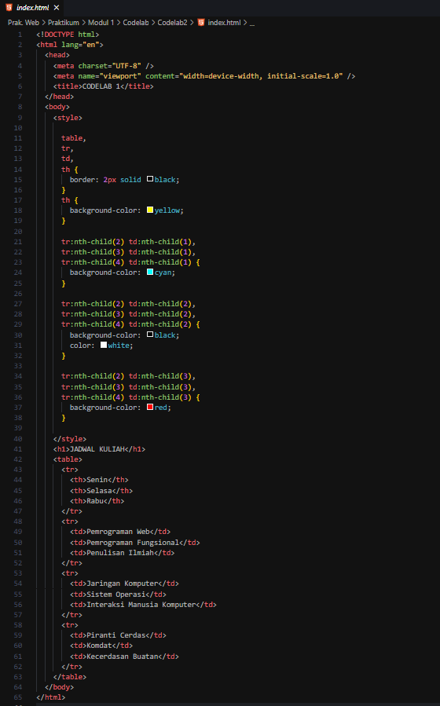

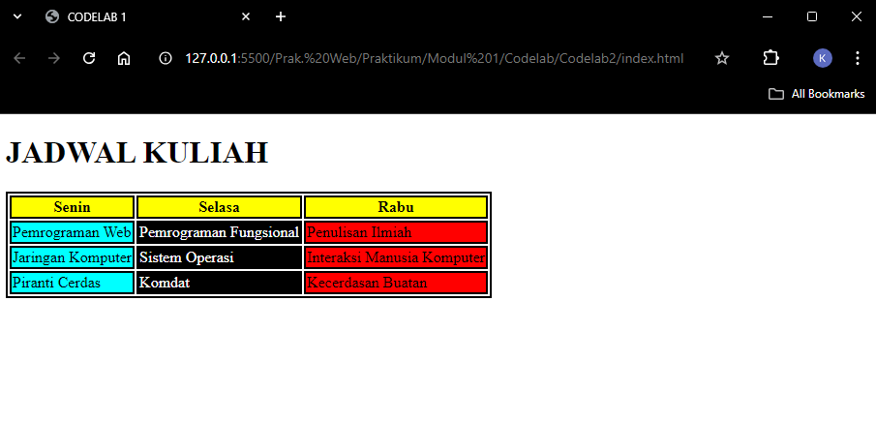

# Codelab 2

